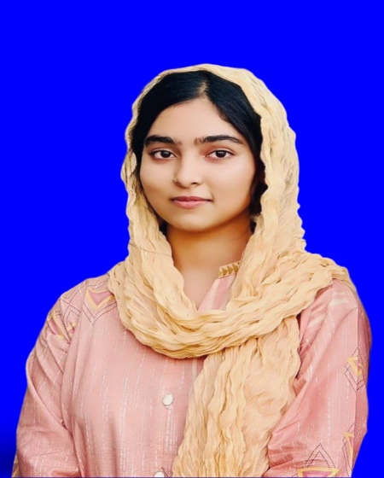

**Bachelors of Computer Science**

University of Engineering & Technology- ( UET-LHR)

March,2023

**Education:**

NetSol Technologies :

* Collaborated with diverse clients to design their desired websites & apps with particular customizations.
* Conducted different seminors as a project leader.

**Experience :**

Jan 2023 – Dec 2024

Detail-oriented with the full stack developer with 2 years of experience designing , developing and optimizing scalable web applications , Profficient in c++ & python with strong background in building APIs and database management using SQL & mongoDB .Known for delievering high level coder.

Languages

Hobbies

Contact

Address

Sargodha , Pakistan

Phone

+ 92 6774935641

Email

taleyaabbas111@gmail.com

* English
* Urdu

**Profile :**

**Taleya Abbas**

programmer

Skills

* Calligraphy
* Editing
* Researching
* Sketching

* Badminton
* Vibing alone
* Writing
* Reading novel
* Cooking